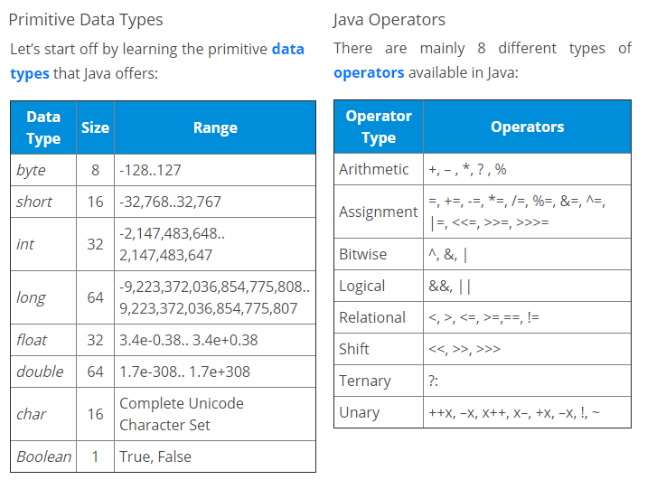

// Using Scanner

Scanner in = new Scanner(System.in);

String s = in.nextLine();

int a = in.nextInt();

// for loop

for (condition) {expression}

// for each loop

for (int i: someArray) {}

// while loop

while (condition) {expression}

// do while loop

do {expression} while(condition)

//if statement

if (condition) {expression}

//if-else statement

if (condition) {expression} else {expression}

//switch statement

switch (var)

{ case 1: expression; break; default: expression; break; }

Prime number?

if (n < 2) { return false; }

for (int i=2; i <= n/i; i++)

{if (n%i == 0) return false;}

return true;

Pyramide

k = 2\*n - 2;

for(i=0; i<n; i++)

{ for(j=0; j<k; j++){System.out.print(" ");}

k = k - 1;

for(j=0; j<=i; j++ ){System.out.print("\* ");}

System.out.println(); }

Arrey (1dim) met random waardes

double[] arr = new double[n];

for (int i=0; i<n; i++)

{a[i] = Math.random();}

Max waarde in een array

double max = 0;

for(int i=0; i<arr.length(); i++)

{ if(a[i] > max) max = a[i]; }

Arrey omdraaien

for(int i=0; i<(arr.length())/2; i++)

{ double temp = a[i];

a[i] = a[n-1-i];

a[n-1-i] = temp;

}

2dim array aanmaken

// Initializing

datatype[][] varName  =  new dataType[row][col];

// Declaring

datatype[][] varName  =  {{value1, value2....},{value1, value2....}..};

Matrix laten zien

for(i = 0; i < row; i++)

{ for(j = 0; j < column; j++)

{ System.out.print(array[i][j]+" "); }

System.out.println(" ");

}

2 matricas maal elkaar

for (i = 0; i < row1; i++)

{ for (j = 0; j < col2; j++)

{ for (k = 0; k < row2; k++)

{ sum = sum + first[i][k]\*second[k][j]; }

 multiply[i][j] = sum;

sum = 0;

 }

}

STRING METHODS

str1==str2 //compares address;

String newStr = str1.equals(str2); //compares the values

String newStr = str1.equalsIgnoreCase() //compares the values ignoring the case

newStr = str1.length() //calculates length

newStr = str1.charAt(i) //extract i'th character

newStr = str1.toUpperCase() //returns string in ALL CAPS

newStr = str1.toLowerCase() //returns string in ALL LOWERvCASE

newStr = str1.replace(oldVal, newVal) //search and replace

newStr = str1.trim() //trims surrounding whitespace

newStr = str1.contains("value"); //check for the values

newStr = str1.toCharArray(); // convert String to character type array

newStr = str1.IsEmpty(); //Check for empty String

newStr = str1.endsWith(); //Checks if string ends with the given suffix

Staat iets al in de lijst?

public void voegStructuurToe(Structuur s) {  
 if (!structuren.contains(s)) {  
 structuren.add(s);  
 } else {  
 System.*out*.println("Deze structuur staat al in de lijst");

